Route Maps for Duluth Expedition – MTB Project

Table of Contents
Sources and References 3
Duluth Traverse Overview (Spirit Mountain to Lester Park Section) 4
Spirit Mountain to Lollygagger (novice) 6
Spirit Mountain (intermediate to advanced) 7
Spirit Mountain Connector to Kingsbury (novice) 8
Kingsbury – Lake Superior Zoo (novice) 9
Duluth Traverse: Kinsbury Creek Traihead Spur 10
Keene – Duluth Traverse to Lollygagger – by Oneota Cemetery 1.5 miles 500 ft v 11
Lollygagger to Enger Park – Overview (separate sections Below) 12
Lollygagger from Keene to Haines Road – Novice 13
Haines Road Parking Lot Notes 46°45'44.8"N 92°10'12.4"W 15
Piedmont & Brewer System – from Oneota Cemetery Parking to Skyline trail – intermediate/novice (Duluth Grill) 16
Stovetop – Upper Burner 17
Skyline trail from stovetop loop – intermediate – 0.8m 18
Lincoln from Skyline to Miller Creek – novice/intermediate 19
Miller Creek: Almost Connects to Enger Trail – novice-intermediate but good climb 20
Enger Trail – from Piedmont/Skyline to Enger Park Observation Hill (novice-intermediate) 21
Enger Park Observation Hill to Observation Road (novice-intermediate) 23
Street Connection – Observation Hill (Enger) to Chester Bowl Rim Trail to Hartley – 5 miles 25
Hartley – Intermediate 26
Tour du Hartley 27
Road Connector from Old Hartley Road to Morningside Trail – 1.8 miles 29
Morningside Trail – Beginner – 2miles 31
Hawk Ridge Trail – Intermediate 33
Lester River Trail – Beginner 3.7 miles 35
Lester Park - Intermediate 37

Sources and References

I have no copyright on this document. It’s a mix of Google maps, REI’s MTB Project maps and descriptions, and a few comments.

- Trail status: http://www.coggs.com/trail-feed-twitter
- MTB Project: https://www.mtbproject.com/directory/8008815/duluth

These maps are sequenced starting at the southwest and traveling northeast. Some of the trail descriptions though go the opposite direction. Top of map is North. I’m sure some of my sequencing is off. Caveat emptor!

Duluth Traverse Overview (Spirit Mountain to Lester Park Section)
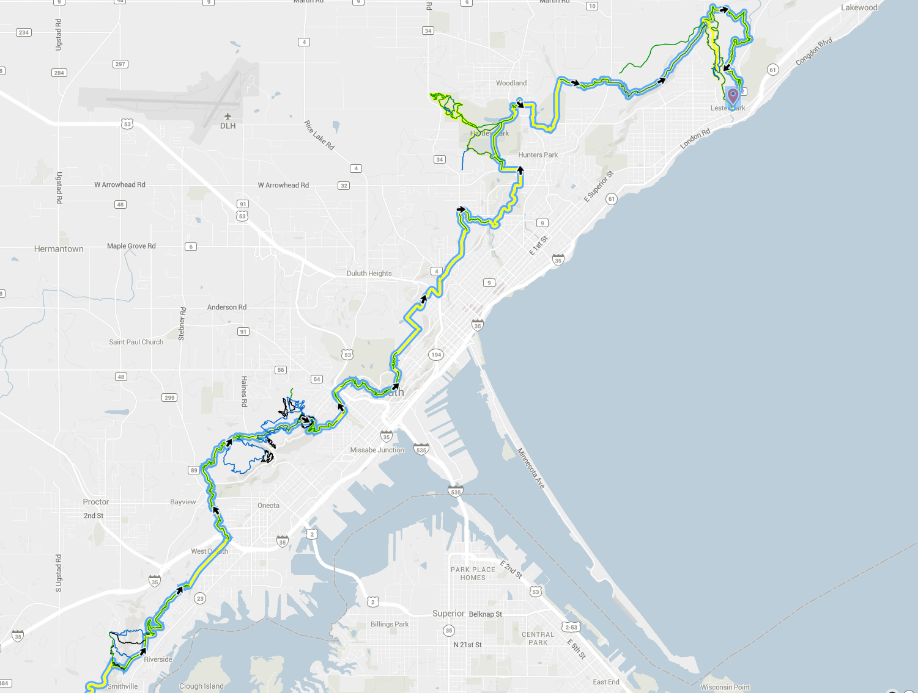
and in Google:

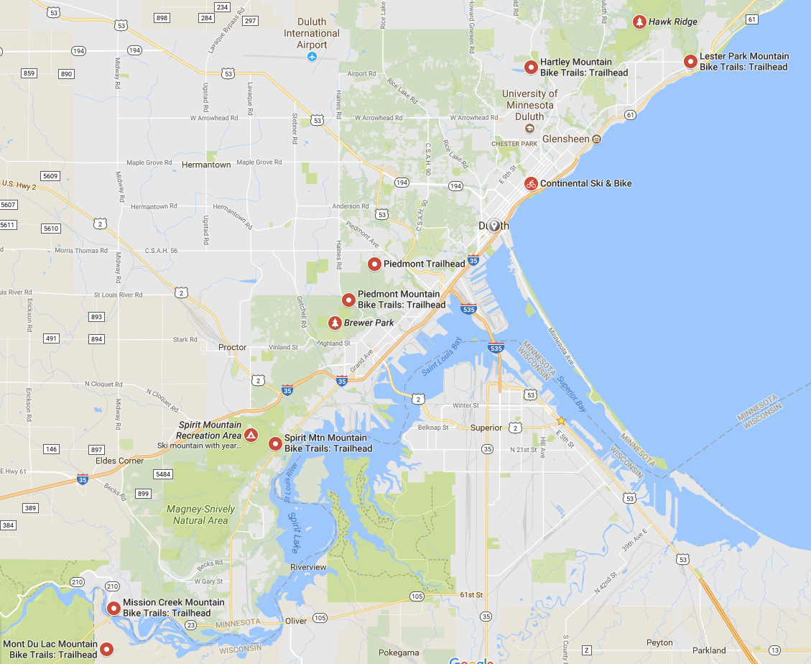

The section from Morningside Trail (north of Hartley) through Snively (bypass Hawk Ridge) to Lester River looks best for my family. This is in a separate document. Spirit Mountain Connector to Kingsbury to Lollygagger is also good, but then I think is novice-intermediate between Lollygagger and Enger -- not so good. Enger Trail Observation Road looks like fun and is approachable, that might be an alternative to the first option.

Spirit Mountain to Lollygagger (novice)
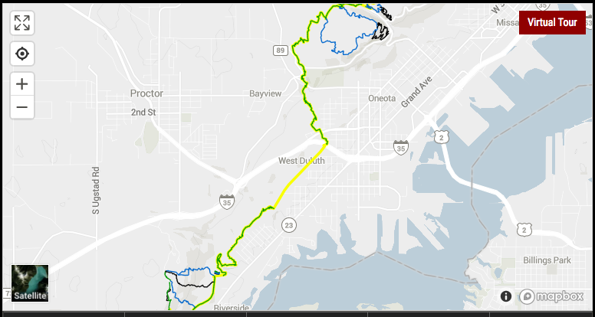

Spirit Mountain (intermediate to advanced)
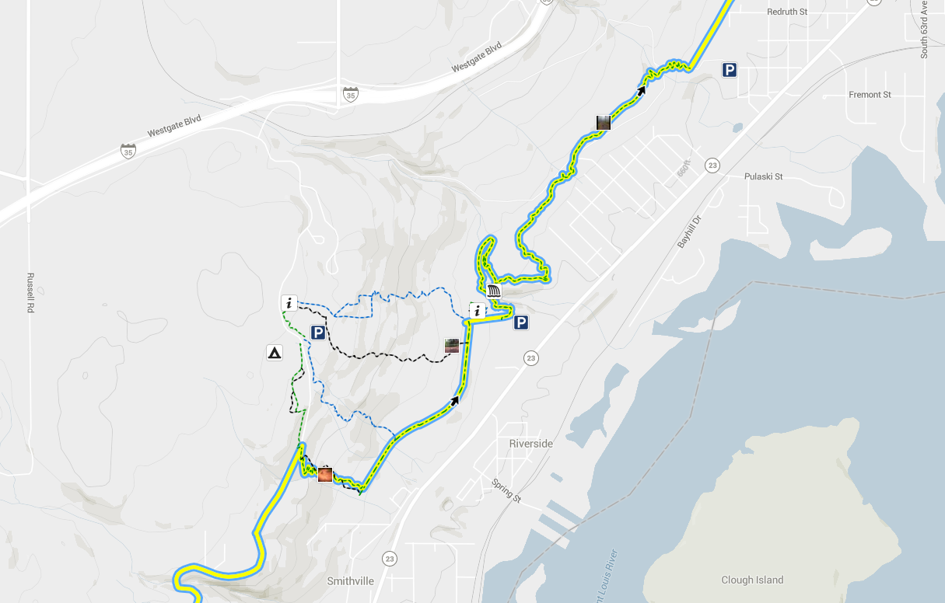
Section ending at Woodruff Street

Spirit Mountain Connector to Kingsbury (novice)
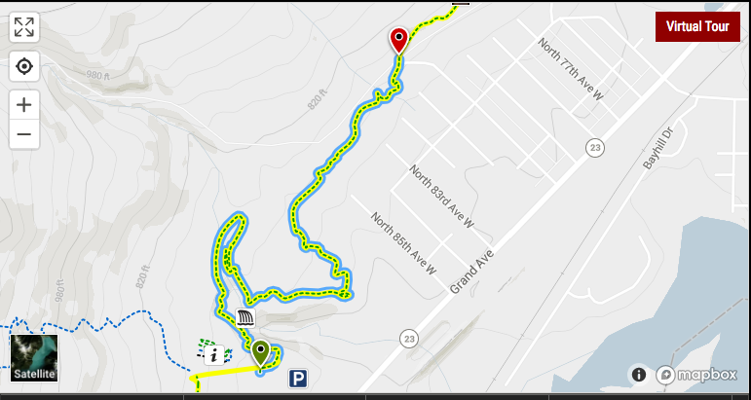
A scenic section of machine-built flow trail near the base of Spirit Mountain. This segment of the Duluth Traverse is accessible by parking at Spirit Mountain's Grand Avenue Chalet, or from the east via the Kingsbury (Duluth Traverse) trail (parking at Waseca St).
The track rolls easily through a variety of nicely wooded terrain. Watch carefully for trail signage, as it crosses several service roads and other trails in the area. There is little elevation gain/loss.

Kingsbury – Lake Superior Zoo (novice)
https://www.mtbproject.com/trail/7026568
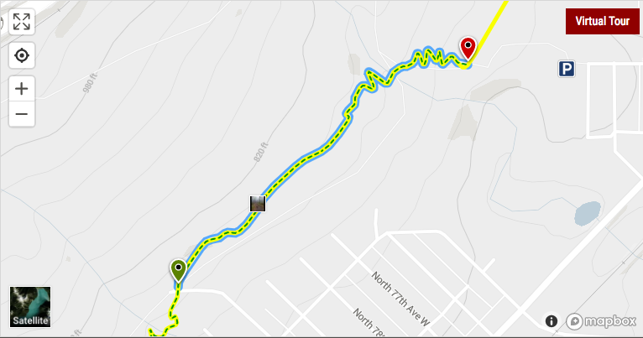
This section of the Duluth Traverse sits between the Lake Superior Zoo and Spirit Mountain. Parking is available near the Zoo (at the Kingsbury Creek Trailhead, off of Waseca St).
The track itself is wide, bermed, machine-built flow trail that serenely rolls through mature coniferous and mixed deciduous forest. The bridge over rocky Kingsbury Creek is a particularly scenic place to stop for a quick rest.
The eastern (top) trailhead is on Waseca Street: 46°43'38.6"N 92°11'26.1"W.

Duluth Traverse: Kinsbury Creek Traihead Spur
Trailhead is near Waseca Street (parking lot): 46°43'38.6"N 92°11'26.1"W. Note parking Waseca Street
Spur Ends at 46°44'19.4"N 92°10'48.0"W (under 35E).
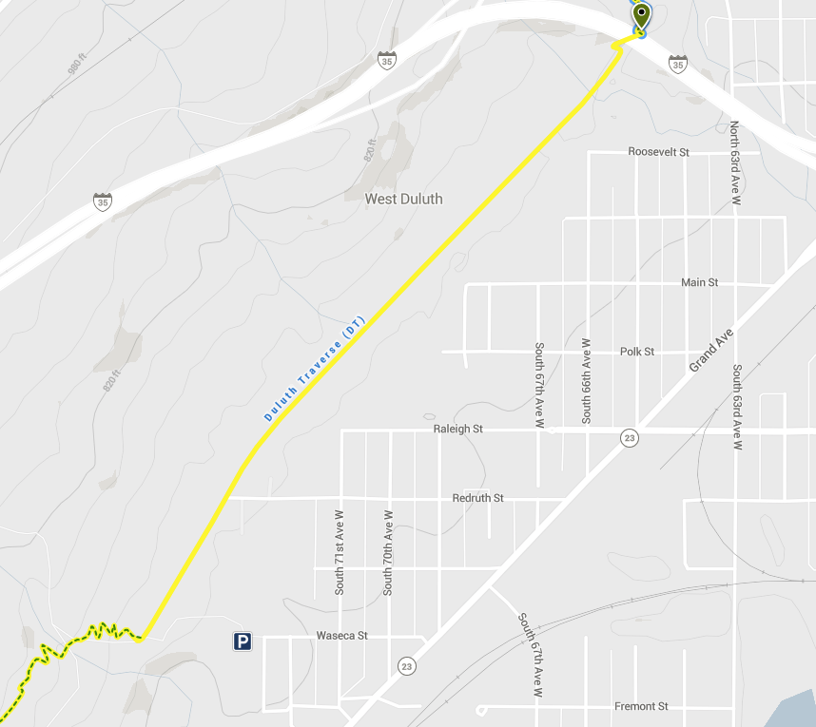

Keene – Duluth Traverse to Lollygagger – by Oneota Cemetery 1.5 miles 500 ft v
https://www.mtbproject.com/trail/7020571
Starts at I-35 Underpass - 46°44'19.4"N 92°10'48.0"W (under 35E).
Parking by Oneota Cemetery: 46°45'01.5"N 92°11'12.1"W
Ends Skyline Parkway near where St Louis River Rd meets W Skyland Parkway: 46°45'20.1"N 92°11'18.7"W
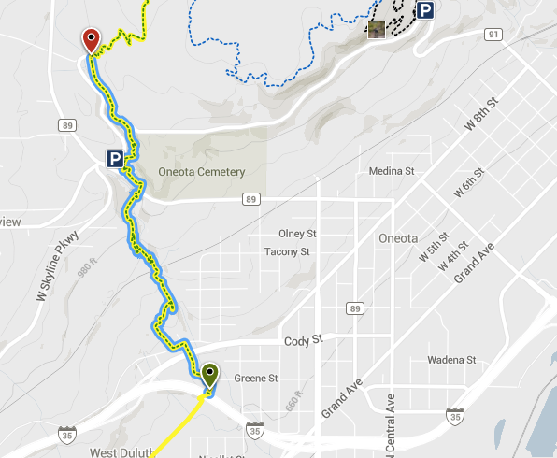

Lollygagger to Enger Park – Overview (separate sections Below)
https://www.mtbproject.com/trail/5739233/lollygagger-duluth-traverse

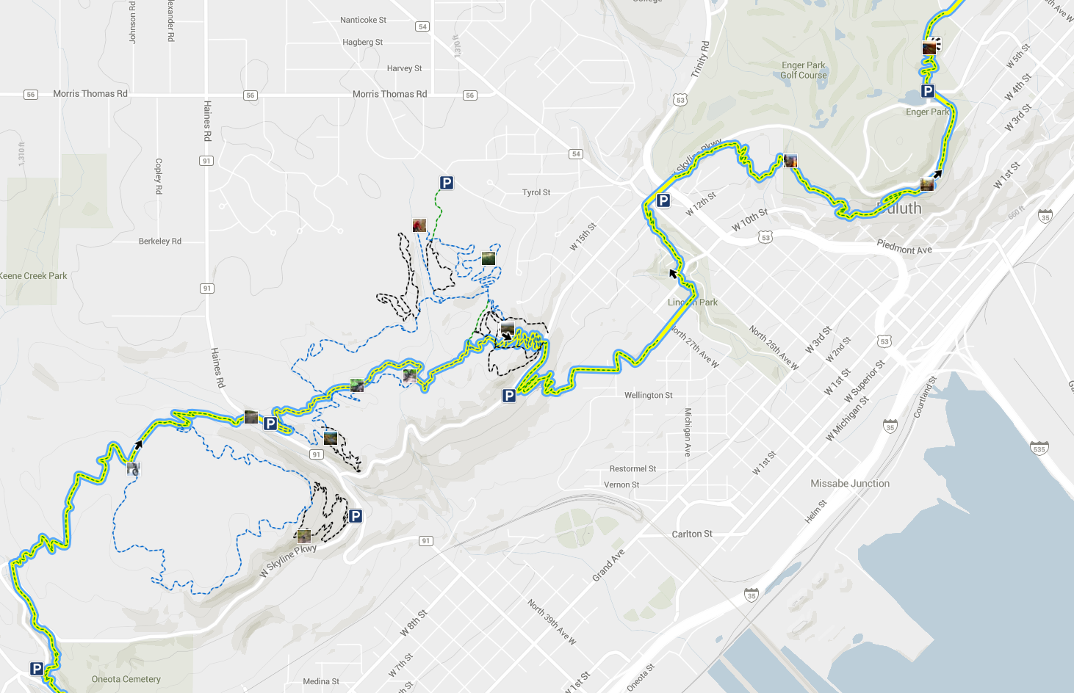
Parking near Oneota Cemetery

Lollygagger from Keene to Haines Road – Novice
Starts Skyline Parkway near where St Louis River Rd meets W Skyland Parkway: 46°45'20.1"N 92°11'18.7"W
Ends Haines Road Parking Lot – Brewer Park Mountain Bike Trails Trailhead: 46°45'44.8"N 92°10'12.4"W
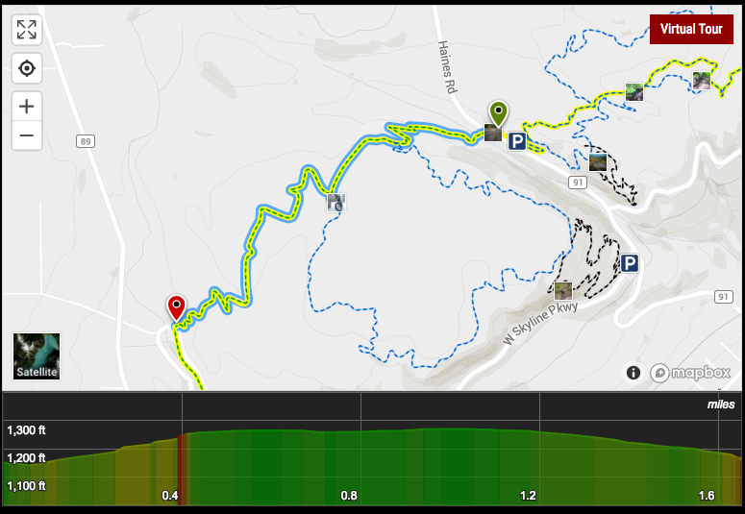
Family Friendly: The trail surface is smooth, and has fun rollers and berms. There is a sustained climb at the start though that younger kids might find to tiring.

Description
This is the easier, more accessible portion of Brewer Park trails. It is still very fun and gorgeous! This trail is also part of the Duluth Traverse singletrack route from one end of Duluth to the other.
Coming up from the tunnel underneath Haines Road toward the intersection with Home Brew, it is a substantial climb. Heading back down, however, it's a beautifully flowing trail, featuring big banked turns.
From its easternmost (lower) intersection with Home Brew, Lollygagger snakes its way southwest, winding through deep boreal and hardwood forest. It's flowing, rolling, machine-built singletrack with moderate climbing. On the way down to Haines Road, the numerous rollers provide smiles for beginners and experts alike.
After some more climbing, you'll pass the upper or western intersection with Home Brew. Turn left to head back down to Haines road on Home Brew, or continue on a few hundred yards of gently climbing trail with a few technical b-line options.
The far west end descends quickly with a few bermed switchbacks to Skyline Pkwy (paved road).

Haines Road Parking Lot Notes 46°45'44.8"N 92°10'12.4"W
Via Doug Kmoch: The Haines Road parking lot is a good starting point to go either way on trail

Go in where the traverse hits Haynes road (little parking lot). Not too bad of a climb into lower burner or the other way lollygagger – a nice section. You can stay and do some of the brewer/piedmont stuff then bike down to Duluth grill and have the “when pigs fly” dessert. That has ice cream, bacon, Hawaiian salt and caramel and maybe other stuff.

Ride from Chester over to Haynes. There is some great stuff between twin ponds and Hanes. And Piedmont/Brewer will have plenty to ride.

Piedmont & Brewer System – from Oneota Cemetery Parking to Skyline trail – intermediate/novice (Duluth Grill)
Many trails here: Home Brew 2.5 mile intermediate, Kissing Booth 0.6 m expert, Foxx Rocks, Stovetop
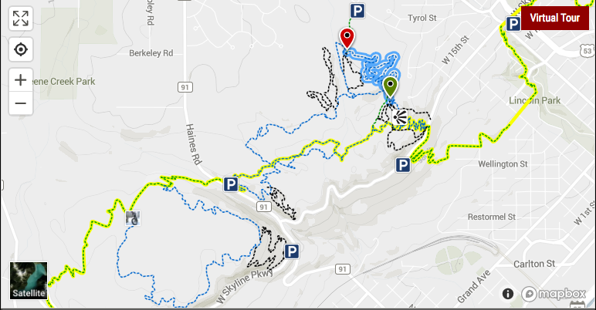
From the lower extension of the trail to Lincoln Park can bike down to Duluth Grill, 118 S 27th Ave W, Duluth, MN 55806.

Stovetop – Upper Burner
Together with Scarface, Deerslayer and either Lower Burner or Foxx Rocks, it makes up the main Piedmont loop, from which all other trails spur off. Rough, rocky, rooty, not all that much fun.
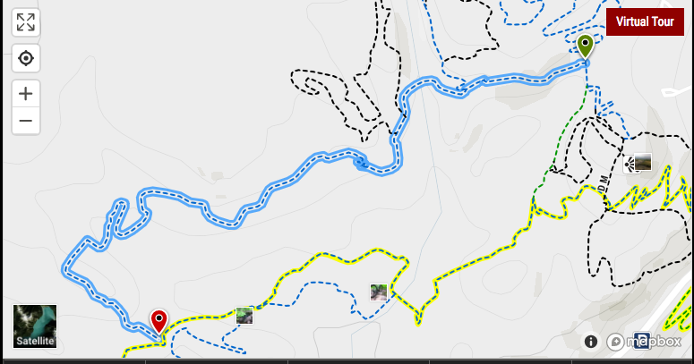

Skyline trail from stovetop loop – intermediate – 0.8m
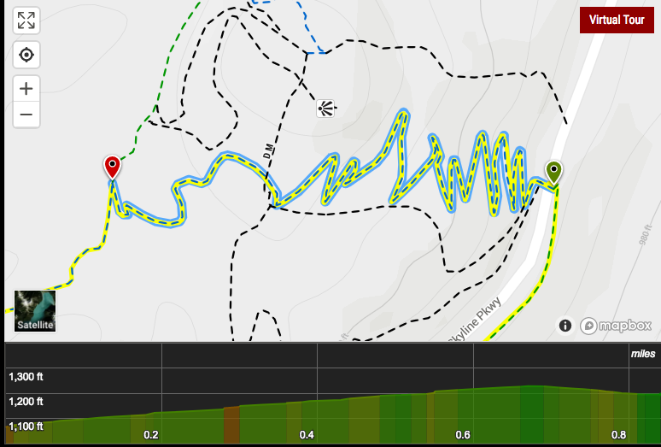

Lincoln from Skyline to Miller Creek – novice/intermediate
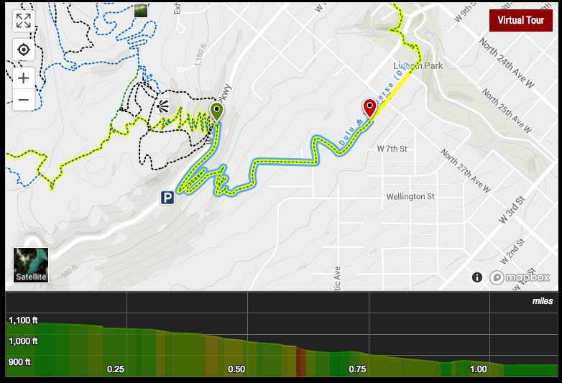

Miller Creek: Almost Connects to Enger Trail – novice-intermediate but good climb
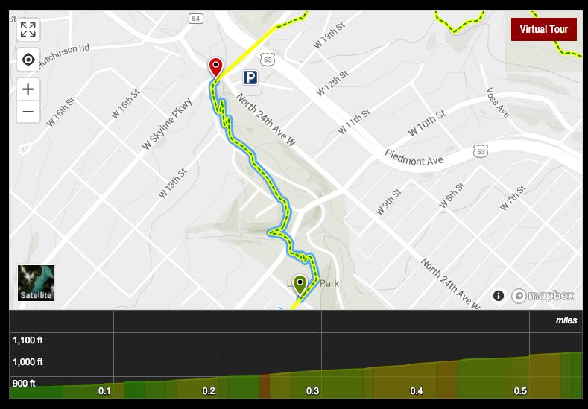

Enger Trail – from Piedmont/Skyline to Enger Park Observation Hill (novice-intermediate)
https://www.mtbproject.com/trail/7008058 The east side of this trail skirts south of Observation Hill with Enger Tower.
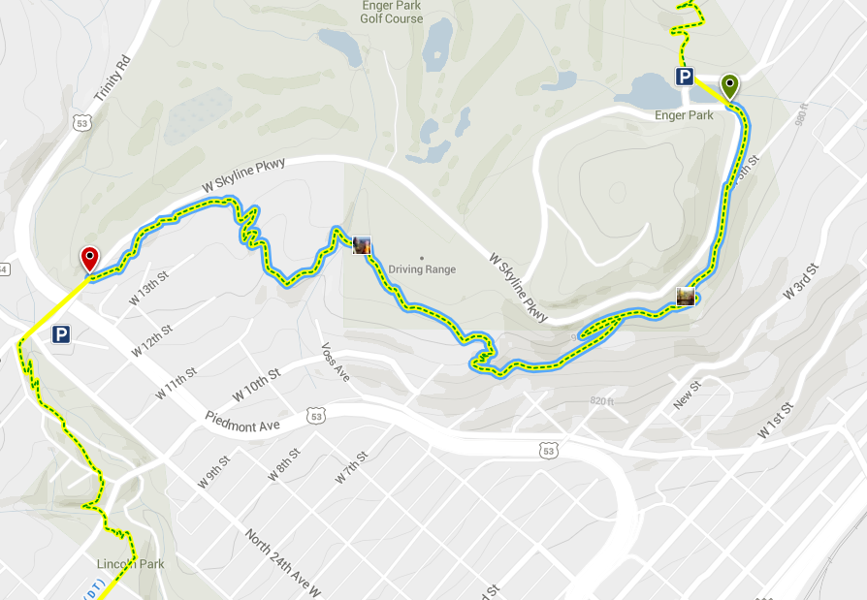

Family Friendly: Wide trail with lots of fun berms and rollers. Little to no exposure. However, there are some sections of bedrock and some pretty significant climbs, so best for slightly experienced kids.

Description (Described from the East (Enger Park, top right on map to the west by Piedmont Ave)
From the southeast side of Duluth's Twin Ponds (small city park) the start of this section intersects Skyline Pkwy (paved road) and descends into the singletrack.
The first (eastern) half of this segment is downhill westbound from Twin Ponds. In general, you'll be making your way down around the knob of rock with the harbor on your left and Enger Tower on your right (way up there). This section has some very fast sections, great berms and rollers to jump and pump. The trail surface is a mix of hardpack, gravel and bedrock here, so pay attention!
After the halfway point, the trail climbs in camel-back fashion up to Skyline Pkwy. The initial portion of the climb has a number of switchbacks then straightens out as you skirt the southern edge of a golf course driving range. After passing the driving range, there is a bit of a descent before the climbing switchbacks resume. Start thinking of the fun you'll have whipping through these tight berms and the way back!
At the far west end, the trail comes out onto Skyline Pkwy (paved road). To continue the Duluth Traverse westbound, stay on the left side sidewalk of Skyline Pkwy across the bridge over US Hwy 53. Go straight across N24th Ave, and turn left, dropping off the sidewalk onto the Miller Creek - Duluth Traverse singletrack along the creek.

Enger Park Observation Hill to Observation Road (novice-intermediate)
Near West 9th street (where road portion extends for a few miles). Park Twin Ponds. Highly recommended.
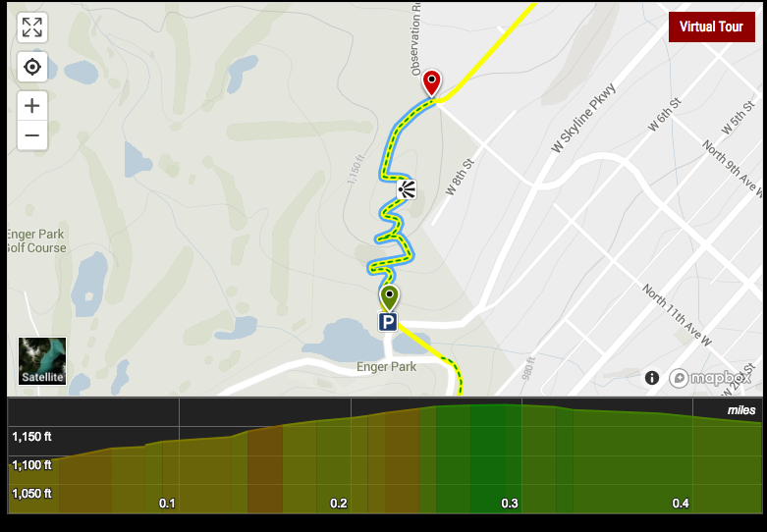
This is a continuation of the Duluth Traverse, connecting Observation Road (paved road) with Twin Ponds (city park). The nearest parking is at the Twin Ponds parking lot.
From the parking lot climb the bermed switchback to a great overlook at the top. Note the rocks and rollers to use as launchpads on the way back if you want to do an out-and-back.
The high point on this trail offers some of the biggest views in town, it's not called Observation Hill for nothing! The last 1,000' of trail is a fast slalom through the woods down to the road.
Between the view and the fun features on the trail, this section should not not be skipped when riding the Enger Trail - Duluth Traverse .
The Enger Trail - Duluth Traverse connects to this parking lot. It's located on the other side of the lower pond (next to the pedestrian crossing dam).

Street Connection – Observation Hill (Enger) to Chester Bowl Rim Trail to Hartley – 5 miles
Observation Road and W 9th Street to Kenwood Ave and Hovland Ln to Chester Bowl Rim Trail (green) to 2032 Hartley Rd, Duluth, MN 55803. (The trail also intersects W Arrowhead but this small terminal difference seemed better to me)
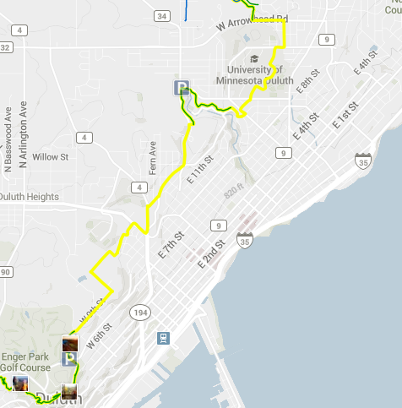

Hartley – Intermediate
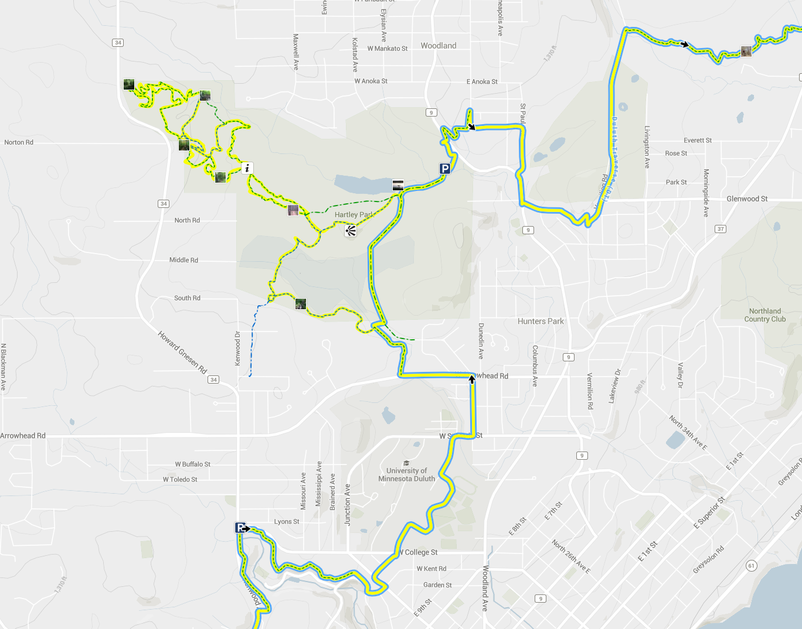

Tour du Hartley

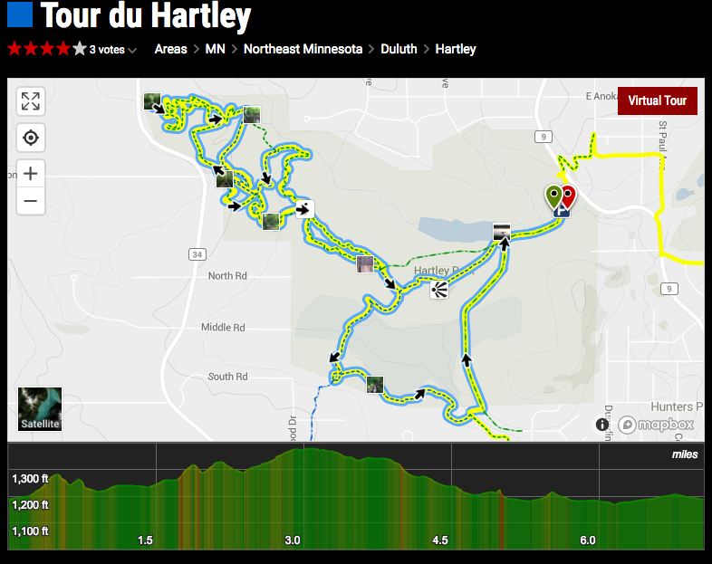

A little bit of everything on this ride that takes you through most of Hartley's trails. Smooth buff trail, tight, twisty old school singletrack, a giant boardwalk and a slick rock dome are mixed together in this northwoods cocktail.
It starts and ends at the Hartley Nature Center Parking lot. This ride can be completed anywhere from 30 minutes (Lycra-clad-racer speed) to 2 hours ("I-drank-too-much-last-night" speed).
Family Friendly: Skipping the Rock Knob (use Tunnel Trail) and Blue pots trails, makes for a good ride for intermediate kids. If they are tired after the Guardrail Loop, simply return to the start from there.
Dogs: Leashed
Description
Head out from the Nature Center on Old Hartley Road - Duluth Traverse, take the second left at the pond, up to Rock Knob,
Climb Rock Knob for some great views and slick rock skills practice, then descend back down into the green tunnel. At the bottom angle right through the pine plantation and take Rhamnus for some fun rollers.
Next up is the flowy forest fun of Guardrail Loop (aka outer loop) with an intermission in the middle to wrestle through Blue Pots (aka inner loop).
After curving back around take the tight and twisty Drunken Fisherman to the pine plantation again. Keep right and take the long, boardwalk across the beaver swamp to Root Canal . After some good effort on the roots and rocks of Root Canal you can cool down with a short spin back to the parking lot on the gravel of Old Hartley Road - Duluth Traverse .
You can ride this one either way, but this way (described), is more fun and more challenging, in my opinion.
The trail names are very well signed, so memorize them and follow the signs. The most difficult way-finding aspect is staying ON Blue Pots long enough: mid-way around Blue Pots there are three distinct intersections (all with the Guardrail Loop) that you should keep right at! If you go left at these intersections, it will put you out on the Guardrail Loop prematurely.

Road Connector from Old Hartley Road to Morningside Trail – 1.8 miles
There’s a small connector through Woodland Park from woodland ave to Allandale Ave & Osakis. From that junction goes to Vermillion Rd and north of amity creek picks up again on Superior Hiking Trail/Morningside Trail (46.8472624, -92.0656942)
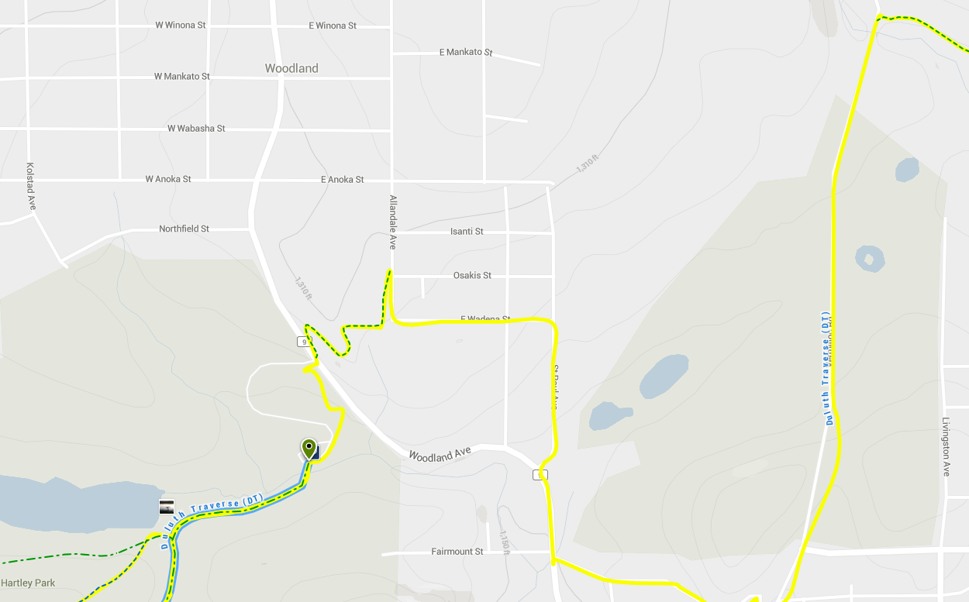

In Google: https://goo.gl/maps/JFdxg2BfdBN2 1.8 miles or 12 minutes
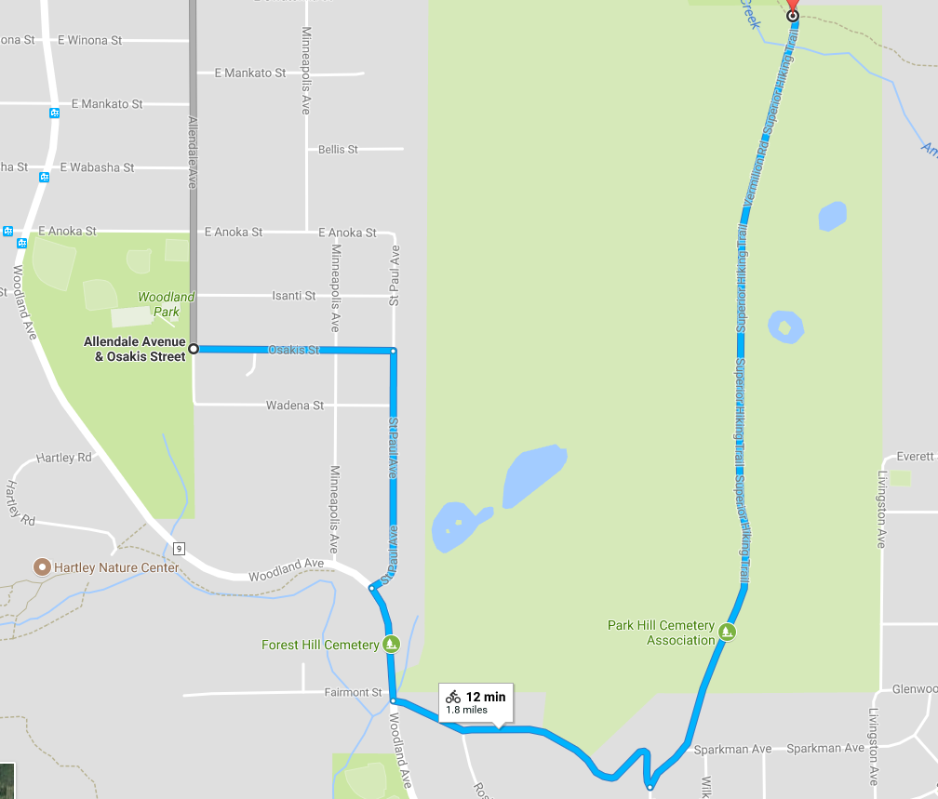

Morningside Trail – Beginner – 2miles
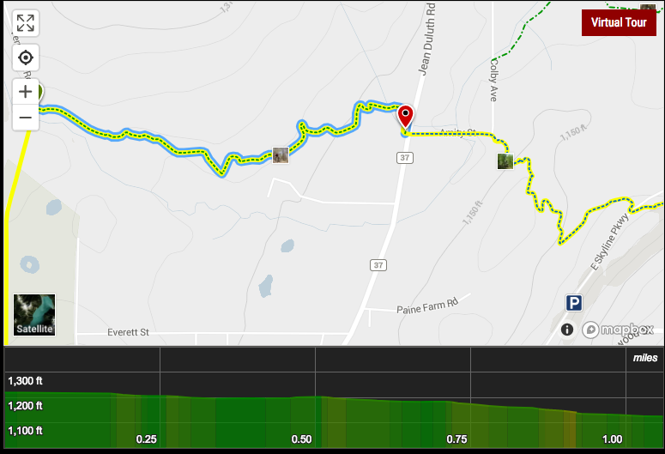
Family Friendly: Fairly smooth and no big climbs. But, there are some gravelly or loose rock sections. Lester River Trail and Upper Cathedral are still a bit easier for young children with little mtb experience.
Dogs: Leashed
Description
This section yields little elevation change overall, but rolls nicely all the way along. It has more of a 'deep woods' feeling to it: no panoramic viewpoints overlooking the city or lake and no rocky ledges. Instead, the track meanders through pine and maple forests on the east side, aspen and oak forests near the middle, and lower wetland shrubs on the west end where it skirts a beaver pond along Amity Creek.
This section is well-suited for families riding with little shredders who are still learning the ropes.
NOTE: the next Duluth Traverse section of the to the east ("Hawk Ridge Trail") is not well-suited for beginners, but it can be easily bypassed by riding eastward on Snively Trail until you come to the bridge over Amity Creek at the top Seven Bridges Rd (paved).

Hawk Ridge Trail – Intermediate
Part of Duluth Traverse but NOT a novice trail

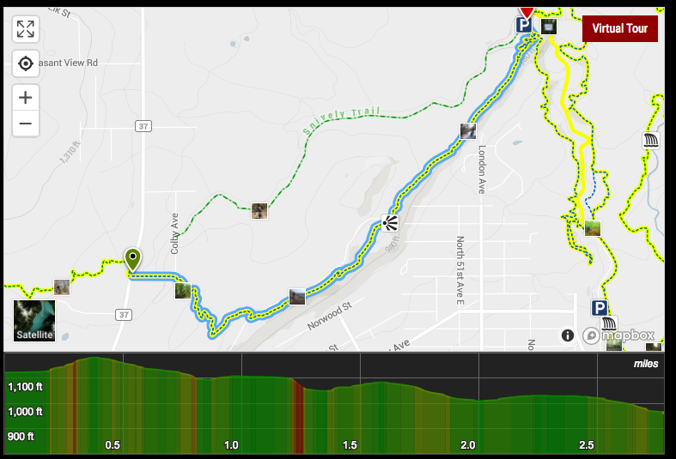
The first few hundred feet of trail (from east-to-west) consists of a short climb with big curvy berms (more fun on the way back down). When you finish this climb, the trail settles into what represents its overall characteristics: rugged rockiness. There is a fair amount of bedrock to rock your socks off, and in between that is mostly broken and crushed rock...some of it a bit sharp. Since the trail parallels the ridge itself (Hawk Ridge - the trail's namesake), there isn't a lot of sustained climbing or descent....just undulation. For technical b-lines, watch the lake-side of the trail where there are at least two opportunities for a descent drop/roll-down (~4'?).
The rattle-factor of this trail makes it tough to classify as "easy". It's probably most accurately described as "intermediate". However, being a portion of the Duluth Traverse ("DT") the hope is that it will be accessible to riders of nearly all skill levels. Note that if this trail proves a bit too much of a beginner, there are ample opportunities to "opt-out" by cutting just a few feet, uphill, through the woods to ride the gravel road just above (Skyline Pkwy).
The views to the southeast are stunning and relentless. You're never more than a few seconds away from a good place to 'pull over' and take in the views of Lake Superior and the City of Duluth below. It wouldn't be uncommon to see a ship or two coming or going from the harbor, and the cluster of sailboats ducking it out in one of the Duluth Yacht Club's week night races. There is one particularly good spot, approximately 1 mile from the east end, where trail skirts around jutting dome of bedrock giving trail users a particularly great view.
Near the western end, the trail crosses to the north side of Skyline Parkway (gravel road). This section rolls nicely up and over a rocky hill. There is a 900' section of road-riding on Amity St (gravel) just east of Jean Duluth Road.

Lester River Trail – Beginner 3.7 miles
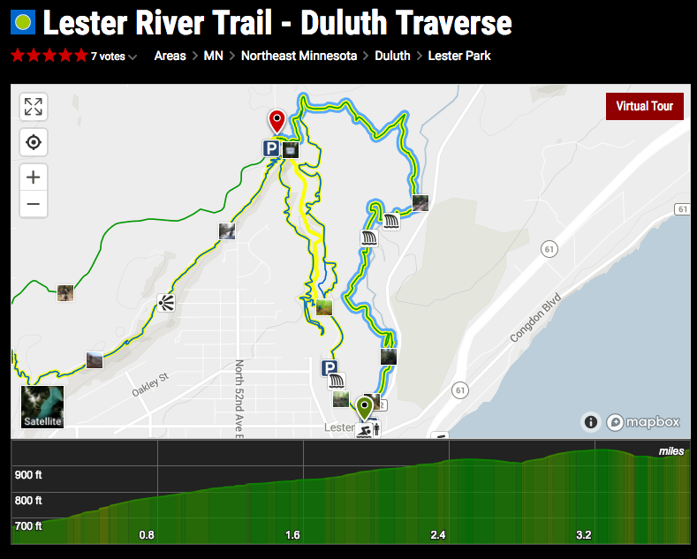
Family Friendly: The trail is wide and smooth. No long or steep hills. For young kids, shuttle up 7 Bridges Rd. and descend on the trail. Perfect swimming hole in the Lester River by the playground at the bottom.
Dogs: Leashed
Description
This is a rolling, bermed, flowing, machine-built stretch of singletrack, generally following the western edge of Lester River.
This trail constitutes the easternmost portion of the "Duluth Traverse", the singletrack trail running from one end of Duluth to the other. The next section, heading southwest is the Hawk Ridge Trail .
This trail is ripping fast both ways: DESCENDING is fantastic and nearly effortless because you can keep your speed through the countless bermed hairpin turns. And if you're ASCENDING (starting from Lester Park), the trail rolls and flows so effortlessly, that you practically feel like you're pumping your way to the top.
As an easy trail, there are no notable riding 'features' and no technical b-lines. But, experienced riders will have tons of fun "narrowing the trail" by simply going faster and riding the roller coaster.
Also, there are several nice scenic overlooks on the east side of the trail, looking down on the Lester River. Especially nearest the bottom, there are a few places where the trail comes close to the edge of the river gorge, which could pose a risk to the very youngest/least experienced riders (however, my 5-yr old handled it just fine by staying slow and in control).
NOTE:
- This is a two-way trail, so watch for opposing traffic
- Also, this is a multi-use trail, so watch for pedestrians
You can make a loop ride by connecting to either Amity East or Amity West trails, or continue across town on the Duluth Traverse.
For less strong, beginner, riders you can climb the very scenic paved road along Amity Creek, called Seven Bridges road. This is far quicker than riding up the trail for a beginner.
Park in the main parking lot at Lester Park to start out with more climbing, or park at the top, where Skyline Parkway intersects Seven Bridges Rd, to start out with more descending.

Lester Park - Intermediate
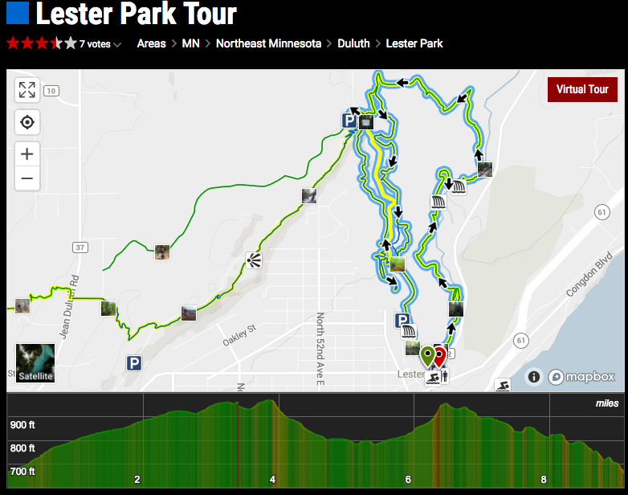
Amity West (4.3) and East (4.7) Trails are also part of this area, also intermediate

Pump up the smoothly-bermed Lester River Trail - Duluth Traverse to the 'top'; ride down Amity West Trail; then up Seven Bridges Rd (paved); and finally, down Amity East Trail.
Dogs: Unknown, please tell us
Need to Know
Two-way traffic on all trails!
Description
This ride offers numerous beautiful views of the river gorges, cascading streams, some smooth, flowing singletrack, and some more rugged old-school singletrack. It covers all of the singletrack in Lester Park by utilizing a short paved road climb mid-way. There are a handful of rocky sections and sections with roots, but overall the trail is not very technical.
Access this ride from the open parking/playground/picnic area. Start by riding up the Lester River Trail, with the Lester River on your right-hand side. This is the eastern terminus of the Duluth Traverse. It's so smooth flowing and bermed that it makes the elevation gain relatively easy! You can practically pump your way to the top. Steal as many glances to the deep river gorge as you safely can.
Continue to follow the Duluth Traverse out of the woods and onto Skyline Parkway (paved road) for a few hundred feet where you'll see it ducks back into the woods on your left. Follow the Duluth Traverse. Shortly after ducking back onto the singletrack, you'll come to an intersection with the Amity West Trail on your left - take that trail downhill.
The Amity West Trail gradually drops you down the hillside, along Amity Creek through twisting curves, narrow bridges, and boreal and pine forests. At the bottom of this trail, you're spit out onto Seven Bridges Road - go left (uphill). Climb Seven Bridges Road (paved) over five of the seven historic and scenic bridges. The views of the river are great.
At the top, you'll turn right onto the Lester River Trail - Duluth Traverse (this is the only section of this ride where you have to backtrack on a little bit of trail that you've already ridden). Follow the Lester River Trail for about 1,500' (until just after a snowmobile trail bridge crossing) where you'll see the intersection with the Amity East Trail.
Take the Amity East Trail on its undulating descent back to the very bottom of Lester Park, where you started.

